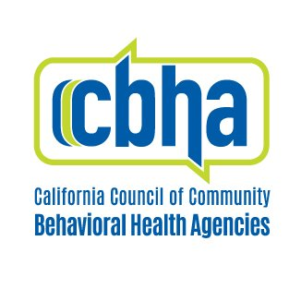
AB 686 (Arambula) California Community-Based Behavioral Health Outcomes and Accountability Review Fact Sheet

Background
Behavioral health inequities across Black, Indigenous, communities of color (BIPOC) communities are unjust, intergenerational, and given the lack of investment, continue to persist despite California’s long stated goals of equity. COVID-19 has exponentially amplified these behavioral health disparities across BIPOC communities.
The absence of uniform statewide performance measures in behavioral health- which encompasses mental health and substance use- has severely limited the ability of the state to hold the county behavioral health safety net accountable for these disparities.

Issue/Current Law
Current behavioral performance measures are out of alignment with California’s BIPOC and LGBTQ+ communities. While reporting is extensive, California’s behavioral health system still contain gaps in understanding how effective existing services are.

This Bill
AB 686 would establish a clear process for stakeholders, including underserved communities like BIPOC and LGBTQ+ individuals, to develop a comprehensive system to evaluate the behavioral health safety that can measure, improve, and evaluate behavioral health equity. Effectively and comprehensively monitoring mental health disparities, access, and quality will enable the state to reduce disparities, improve quality, increase access and reduce cost.

Specifically, this bill will:
- Task a workgroup under the California Health and Human Services Agency (CHHS) to identify a set of measures the State and counties shall use to reduce behavioral health disparities and improve behavioral health equity.
- Center community-defined, culturally centered and consumer focused practices that can offer a role in the State’s efforts to reduce behavioral health disparities and advance behavioral health equity.
- Require the new methodology to take into account cross-system measures related to wellbeing and social determinants of health, including but not limited to other Medi-Cal delivery systems, housing status, education, employment, justice involvement and any quantifiable disparities.
- Require the workgroup to develop a standard, statewide method for counties to collect race, ethnicity, language, sexual orientation, and gender identify to provide the state and stakeholders more robust data.
- Inform and guide local stakeholders to assess the performance of counties on the established measures and inform a system improvement plan, which will require the county to describe how it will improve its behavioral health services with a focus on equity and reducing disparities.
- Require the behavioral health system improvement plan to include a peer services review element where one community can provide insight and technical assistance to another community.

For questions, please contact Ronald Coleman at rcoleman@cpehn.org or call 916-447-1299 ext. 104

