
For further assistance, please call:
When You Can’t Talk to Your Doctor:
Understanding your rights and responsibilities when you need language services.
Asian Pacific American Legal Center
213-977-7500
This brochure is available in Hindi, Urdu and Bangla through the generous support of the South Asian Bar Association Public Interest Foundation.




CHEST PAIN
Skin?
Muscle?
Bone?
Lung?
Heart?
Nerves?
Good communication is important…
Because doctors rely on what you say to decide what tests to order or what treatment to try.
When You Cannot Talk to Your Doctor…
- You cannot explain what is bothering you.
- You may not understand the treatment the doctor recommends.
- You can get confused about medications.
- You may feel frustrated or angry.

Curriculum by Language Access Advocacy Project: Asian Pacific American Legal Center, Asian Pacific Islander American Health Forum, California Pan-Ethnic Health Network, California Primary Care Association, Latino Coalition for a Healthy California, National Health Law Program. Supported by The California Endowment. “I Speak” Card by PALS for Health, www.palsforhealth.org.
“I Speak” Card by PALS for Health. www.palsforhealth.org

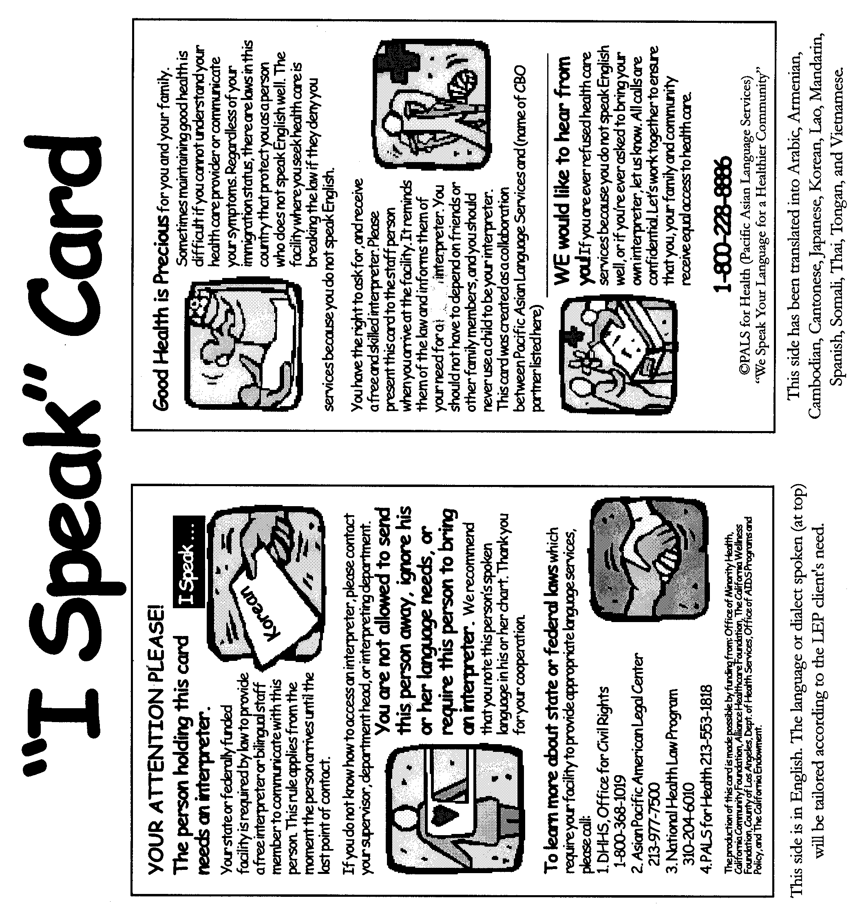
- Their English may not be good enough.
- Some people, especially children, are not fluent enough in your native language.
- If they do not work in the
medical field, they may not
know important words or
concepts.
- They often forget to interpret important things you say.
- Sometimes they may have their own opinions or goals.
- It may be embarrassing for you or for your
family member if sensitive issues come up.
- There are issues that you may want to keep
private. You have a right to privacy.

See inside for…
- Your right to a trained interpreter
- How to get a trained interpreter
- How to talk with a trained interpreter
- What to do if you cannot get trained interpreter
- Tips on communicating with your doctor
…appendix, arthritis, chemotherapy, hemorrhoid, thyroid, ultrasound, virus…
Family and Friends May Not Be the Best Interpreters:

Trained medical interpreters:

Are fluent in both languages.
Have studied medical words.
Have good memories so they can repeat exactly what the patient and doctor are saying.
Keep everything that the doctor and patient say private.
Talking with Trained Interpreters:
- It is best to use a trained medical interpreter.
- After you talk, pause. That way, the interpreter can say what you said to the doctor.
- Try not to interrupt the interpreter. It can make them forget information.
- Interpreters are not there to give medical advice. They are there so you can get medical advice from
your doctor.

If I Have a Right to an Interpreter, Why Don’t I Get One?
- There are laws, but they are not always obeyed.
- There are not enough trained medical interpreters.
- There is not enough money to pay interpreters

What if I Don’t Get an Interpreter?
Make a complaint with the hospital.
Make a complaint with your health insurance plan.
Work with community organizations.
Make a complaint with the federal Department of Health and Human Services’ Office for Civil Rights.



Communicating With Your Doctor

- Write down your questions before your appointment.
- Bring the list with you to your appointment, and show your doctor your list at the beginning of your appointment.
- Do not wait until the end of your appointment to give the doctor your list of questions.
- Work with your doctor to decide what is the most important thing to discuss at each appointment.
- Ask questions if you do not understand something or want more information.
- Bring all your medications to every visit.
- Keep each medication in its own bottle.
- Bring a friend or family member to take notes and to help you remember things - not to interpret!


You Have a Right to an Interpreter:
- If you are hospitalized.
- If you are a member of a Medi-Cal or Healthy Families HMO.
- If you are a member of a private HMO in California.


How Do I Get an Interpreter?¹
- When you call to make an appointment with the doctor, ask for an interpreter.
- Ask your doctor or nurse to call a telephone interpreter.
- Call your health insurance plan to ask about how you get an interpreter.
- Use an “I Speak” card.

Make sure you leave each visit knowing:

What are my main problems?
What do I need to do? Why is it important for me to do this?
I need a
(your language) interpreter.

Useful Resources
- Health Consumer Centers http://www.healthconsumer.org/
- Office for Civil Rights http://www.hhs.gov/ocr/lep/
- “I speak card” samples http://www.dss.cahwnet.gov/civilrights/ISpeakCard_1304.htm

¹ You have a right to an interpreter: 1) Because of federal law. (Title VI of the 1964 Civil Rights Act), 2) Because of regulations from the Centers for Medicare and Medicaid Services, 3) Because of California laws, 4) Because of California contract requirements with Medi-Cal and Healthy Families HMOs.

